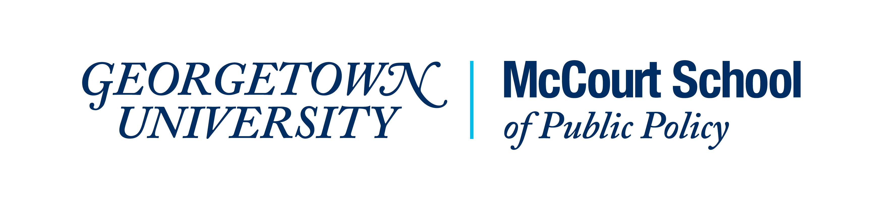

The Better Government Lab at the McCourt School of Public Policy at Georgetown University, in collaboration with the US Office of Management and Budget and the Office of Science and Technology Policy, invites participants for a roundtable on the President’s Management Agenda, in support of the “Year of Evidence for Action”. This half-day event will bring together public management scholars and federal government officials charged with implementing the President’s Management Agenda learning agenda to explore research opportunities, especially as it relates to questions of how the Federal government can strengthen its workforce, deliver programs and services effectively and advance equity and support underserved communities.
This event is co-sponsored by the Public Management Research Association to facilitate access to a diverse group of scholars. The event will be hosted at the Georgetown University campus from 1-5 pm, Wednesday, November 16, 2022 (the day prior to the start of the annual APPAM meeting in Washington DC). Those interested in participating should apply online [​​https://forms.gle/nfX2kGKrvbGGvZ478], with a short description of the topic they are interested in by October 1, 2022. A limited pool of funds are available to offset travel costs for applicants from underrepresented backgrounds (including those from institutions with limited travel support), so please indicate if you will need such support.

